## Optimization Report

Investigation was done into the installation of a PHP accelerator to optimize our program to improve performance.

Upon investigation into our installation of PHP, I learned that the “Zend Optimizer” OpCaching service was already included and enabled in the server’s installation of PHP. This is a standard PHP accelerator utility. We evaluated this as sufficient use of a performance enhancing utility for this project.

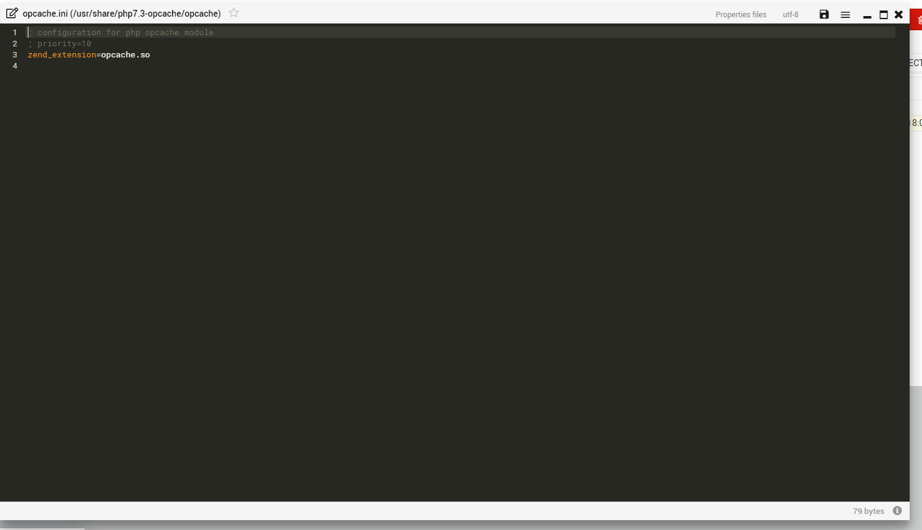

Builtin Opcaching configuration on the server

At the time of writing, performance concerns are a lower risk factor in the development process. If this situation changes, this topic will need revisiting to further address performance concerns in more detail.

In the case that performance becomes an issue, our next avenue of investigation is manual analysis and optimization of our table generating code.